

**UNIVERSITY OF MASSACHUSETTS DARTMOUTH**

**DEPARTMENT OF COMPUTER & INFORMATION SCIENCE**

**Spring 2016**

**CIS 600: MASTER’S PROJECT**

**Final Project Report**

**Analyzing Geospatial Data with Hexagonal Binning**

**PROJECT ADVISOR:**

**Dr. David Koop**

**PRESENTED BY:**

**RISHU VAID**

**ID: 01490974**

**ABSTRACT**

The increasing number of data, either owned by companies or collected by Internet of Things, is posing a new challenge and creating an opportunity as well to extract meaningful information from it. But to be able to understand the data, it has to be converted into useful information or into a form that could be comprehended. There comes ‘Data Visualization’ into picture. Data scientists take the help of visualization idioms like bar charts and scatter plots etc to visualize statistical data. But we need different idioms to visualize geographical and geospatial data. This project focuses on building tools to analyze and visualize geospatial data.

The project attempts to analyze the Marine Traffic Data, which is recorded by US Coast Guard through Automatic Identification System (AIS) receivers. Most of the ships or vessels in the waters are installed with AIS receivers that transmit its geographic points and other information about the vessel after every minute and the data is recorded at the other end in Geospatial Database file (.gdb) format.

The project uses hexagonal binning as the core algorithm for analysis. It creates a grid of hexagons over the geographic map and the color of each hexagon is encoded by the value of a defining variable (in this project, it is the density of vessels). Thus the color of hexagon tells the amount of traffic density under that hexagon area. The project has two dimensions that it analyzes. They are ‘Traffic Density’ and ‘Traffic Direction’.

Because of its powerful data manipulation libraries, Python is used as the scripting language. Libraries like Matplotlib, Pandas and Basemap are used for data manipulation. Data extraction is done with Geospatial Data Abstraction Library (GDAL) and OpenGIS Spatial Reference System (OGR). Folium is used for data rendering on the map.

**TABLE OF CONTENTS**

1. Introduction ……………………………………………………….1
2. Background Work ………………………………………………...2
3. Motivation ………………………………………………………...4
4. Improvement ….…………………………………………………..5
5. Algorithm Used: Hexagonal Binning …………………………….7
6. Why Hexagon …………………………………………………….8
7. Project Details …………………………………………………….11
8. Approach Used For Traffic Density ..…….………………….……15
9. Results of Traffic Density …………………………………………16
10. Approach Used for Traffic Direction ……………………………...20
11. Results of Traffic Direction ……………………………………….22
12. Evaluation …………………………………………………………23
13. Future Work ……………………………………………………….24

1. References …………………………………………………………25

**INTRODUCTION**

The use of Google Maps for traffic analysis on roads is becoming more popular as traffic on roads are getting denser and people are getting more busier in life. Thus, people tend to save more time by shifting their travel routes as per the traffic conditions.

We have defined paths/roads for land and so the techniques for traffic analysis are easier to apply. For example, the red color road visualizes denser traffic as compared to the road colored green or yellow on Google Maps.

But, Ocean does not have defined paths. Thus, different techniques are needed to analyze traffic in the open waters. But, why do we need to analyze ocean traffic? Lets take an example that if someone wants to plan a wind farm in the ocean. Definitely, the ocean region having usually a dense traffic should not be chosen for this purpose. Also, if someone wants to identify the areas of high demand for safe navigation or want to plan the ship routes for marine life preservation in times of need, the need of tools for ocean traffic analysis comes into practice. Thus, we need to develop specific analysis techniques, which could provide us meaningful visualizations to analyze trends in the ocean traffic.

**BACKGROUND WORK**

The background work on ‘Marine Traffic Data’ that was referenced for the project had used different algorithms. A few only plotted the points; others built the line string from the vessel coordinates of the voyage. And, some used colors to show the intensity.

**Figure: Point plot & Line Plots**

One of the algorithms used was the point plotting over the map. In this, every geographical point recorded is plotted on the map that helps to plot the locations where the vessels have crossed or visited. When all the vessels and their geographic points are plotted on the map, it shows the more denser points on locations having more traffic and less denser points on the areas having less traffic. But this algorithm has a drawback when the scale of the map is large enough and the data is also dense. In such a situation, most of points are overlapped with other points giving the wrong impression of lesser points because only the upper layer of points gets visible and underlying points gets hidden. Even if the map is zoomed in to see the separate layers of points, it hinders the capability of having an overview of whole data all together. Distinguishing and identifying the paths followed by the vessels also becomes difficult as it becomes impossible to identify that which coordinates belong to which vessel when a large number of vessels are plotted together.

Another algorithm referenced was plotting the line strings of vessel paths over the map instead of separated points. This type of algorithm plots the paths that vessels take. It gives sense of the actual paths followed by individual vessels in the ocean than just the geographic points it went to. It becomes feasible to identify a continuous path of a vessel since the line string plots a continuous line or path from the start to end of the vessel voyage. But this algorithm also has the same drawback of overlapping data as in case of plotting points. If there is more than one vessel taking the same approximate path on the map, only a single line gets visible as the entire vessel paths get overlapped by one vessel data. Thus, showing the comparative density of paths or the area on the map is not an efficient task.

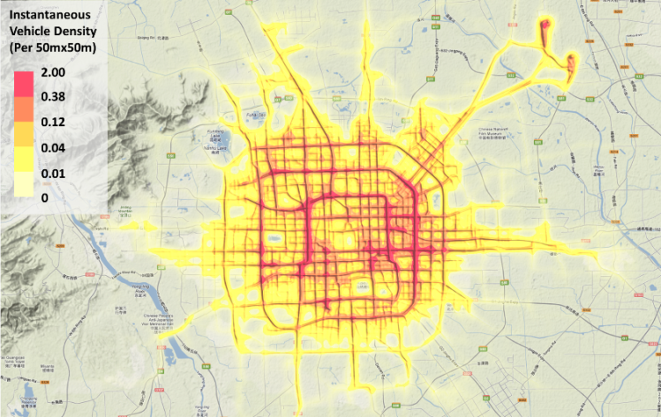

Zuchao Wang, Xiaoru Yuan, 2012

**Figure: Traffic density map of 28,519 Beijing taxis in Mar 8th, 2009**

Another approach to show the comparative density on the map is the technique used by Google Maps. This project also references Google Maps in terms of how the color map is used to show the density of traffic with the help of colors. In Google maps, the part of the road having denser traffic is colored red and less dense traffic is shown by yellow and green colors.

**MOTIVATION**

The motivation of this project is the visualization technique used by Google Maps to analyze and display traffic density on the roads. Google Maps is a very useful application used commercially by travelers or drivers for understand the general route, traffic direction and its density most importantly. People can easily manage their travel time and conditions by understand the traffic pattern on the route they plan to travel. Google Maps use color-coding for different intensity of traffic. For example, the roads having dense traffic at that point in time is colored red. Yellow and green are the colors used to show low and moderate traffic.

But the data in this project is different than the one usually plotted on Google Maps because there are no specific streets or roads in the ocean. The ship traffic can take any path in the ocean and thus have no restricted paths except some special cases. Thus, a different visualization technique had to be chosen to explore and understand the trends in ocean traffic.

Further the software like Quantum Geographic Information System (QGIS) and Arc View Geographic Information System (ArcGIS) are used as a reference and motivation to decide and develop the appropriate technique for Ocean Traffic Analysis. The idea behind was to keep the geography and the data values intact for the complete information. The challenge was to choose the technique that should visualize this effectively.

**IMPROVEMENT**

As discussed in the background work, using algorithms that plot points or line strings have certain limitations. In general, these algorithms are not able to display or effectively communicate the trends in the traffic density since some data gets overlapped. Moreover plotting large number of points on the map makes the algorithm computationally very slow.

Moreover, the algorithm used by Google Maps does not fit well for ocean traffic data since ocean does not have specific and defined streets. But the idea of using color-coding for comparative density seemed to be an efficient technique.

Further exploring the similar geospatial analysis tools like Quantum Geographical information System (QGIS) and ArcGIS, algorithms like heat maps and gridding seemed appropriate. By combing both the above-mentioned techniques, binning algorithms were taken into consideration. Binning algorithms divides the data set into equal sized bins and associate a value to each bin. Since the data used in the project is a geospatial data so the bins correspond to equal sized area on the map, which is associated to the value of density of points under each area.

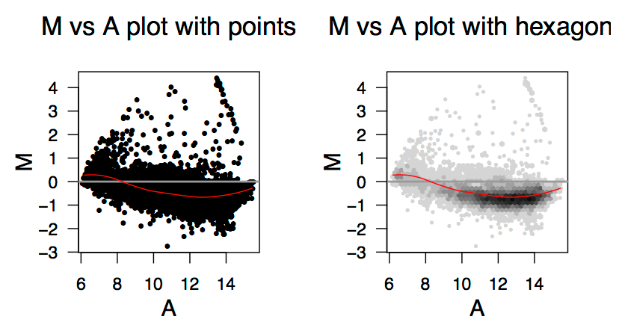

Nicholas Lewin-Koh, 2011

The above figure compares the difference between point plotting and binning algorithm. The first picture plots M versus A data with points where it is difficult to analyze density in different regions of the plot because of overlapping of data points. I second figure, binning algorithm is used and one can see easily from the color of polygons that there is dense data towards the right centre as compared to the edges.

The next challenge was to choose the bin shape, which should be able to effectively sample the data for effective analysis. Based on the related research paper byNicholas Lewin-Koh (2011),hexagon was chosen over any other polygon shape (For example, triangles or squares) to create the grid over the map. The reasons for choosing hexagon over square or triangle are discussed in the next section.

Thus, the algorithm used in the project is called ‘Hexagonal Binning’. In hexagonal binning, the surface of the map is tiled with hexagons to create a uniform grid. Then, the number of points in each bin or tile is calculated and color encoded. Thus, color of each hexagon tells the density under it. This algorithm is an example of data aggregation and is considered very efficient for analyzing large data sets.

**HEXAGONAL BINNING: THE ALGORITHM**

Hexagonal Binning is an algorithm to divide a large data set into small equal size sets or bins. Each bin is associated with a value that the algorithm intends to represent and analyze. In other words, the surface is tiled with uniform grid of hexagons and the color of each hexagon is encoded by the value of the parameter associated. Thus, the color of the hexagon helps to analyze the value under the hexagon area. It is also called a spatial histogram create with hexagon shape.

Example:

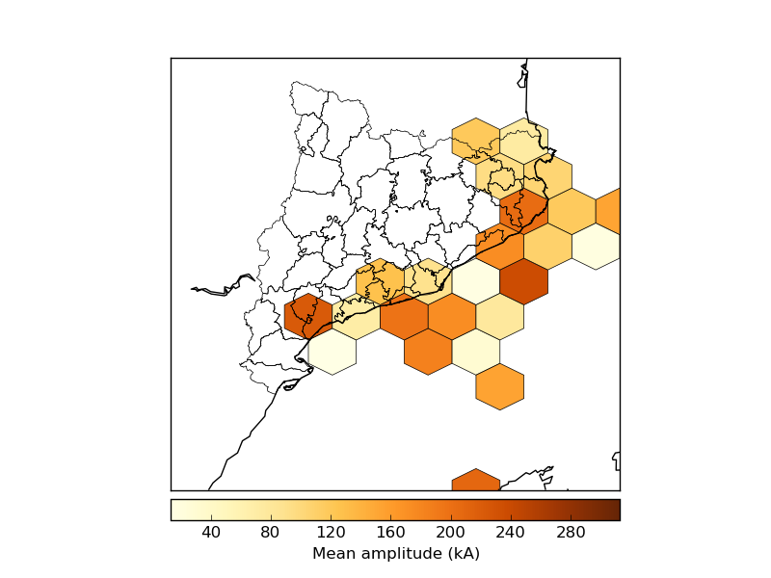

basemaptutorial.readthedocs.io

The figure above shows the example of hexagonal binning algorithm. In this, the map is covered with tiles of hexagons. Each hexagon is associated with the value of ‘Mean Amplitude’ of the area the hexagon is covering. The color of hexagons tells the value of the mean amplitude. With the help of colormap, it is easy to analyze the comparative value of the variable of the areas on the map.

**WHY HEXAGON?**

The polygon that is chosen for creating the grid should be able to cover the whole surface uniformly without the use of any other shape. Now the question is that why only the hexagon is used and not any other polygon, for example, square or triangles etc.

Based on the related research paper by Apte M., Agarwadkar Y. Y.Y., Azmi S., Inamdar A. B. (2012), the efficiency of shapes chosen for grids are compared based on their ability to have comparable grid distances to real distances. And the resemblance to reality corresponds to similarity of the below properties:

* Mapped and actual distance
* Areal Coverage
* Maintenance of angularity & linearity of distance.

Before evaluating the properties for every type of polygon in discussion, it is important to understand and know a few properties of grids using different shapes.

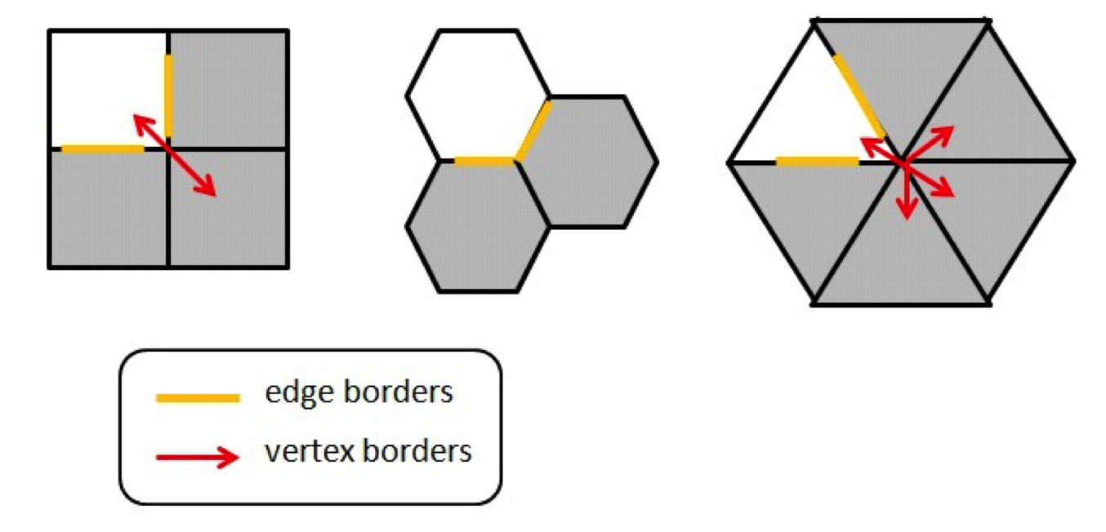

[www.meccanismocomplesso.org](http://www.meccanismocomplesso.org)

In general, the distance between a polygon to its neighbors is measured from the center of the polygon to the center of neighbor polygons.

In square grid, a square has neighbors that share the edge borders and some neighbors are due to vertex border sharing. Triangle grid is the same like square grid in a way that a triangle has some of its neighbors due to edge sharing and some are due to vertex sharing. But in hexagon grid, a hexagon has all its neighbors due to edge sharing and there are no neighbors due to vertex sharing.

Now, lets evaluate the properties mentioned above, for resemblance to reality, for different grid types.

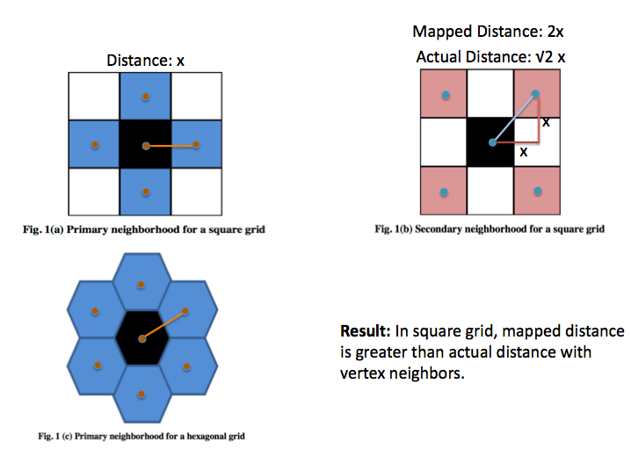

Apte M., Agarwadkar Y. Y.Y., Azmi S., Inamdar A. B., 2012

**Similarity of Mapped & Actual Distance:**

As seen in the picture above, in square grid, the distance between two squares sharing the edge is lets say ‘x’ units. But, the mapped distance between centers of squares sharing vertex border is ‘2x’ units and in this case the actual distance (diagonal distance) is ‘√2 x’ units. Thus, in square grid, the mapped distance is greater than actual distance with vertex neighbors. In the same way, in triangle grid, the mapped distance and the actual distance between two triangles sharing vertex border are not equal.

But in case of hexagonal grid, the hexagon has all its neighbors due to edge sharing. Thus, the distance of center of a hexagon to the center of its neighbors is equal for all its neighbors. Hence, the mapped and actual distances between hexagons are equal.

**Areal Coverage:**

If the hexagon and square of equal area are considered, the perimeter of hexagon is shorter than that of hexagon. This reduces the amount of edge effect errors. Edge effect means error due to the points lying on edges of the shapes. Such points are not considered in any of the polygons or are considered in all the polygons sharing that edge.

**Maintenance of Angularity:**

In case of triangle grid, the orientation or the angularity of the triangles need to be altered in order to create a uniform grid. This irregular orientation of the triangles makes the computation difficult and complicated. Thus triangle grid is not preferred.

In conclusion, counting all the three above-mentioned properties to evaluate the efficiency of grids of different polygons to cover the surface uniformly, it is concluded that hexagonal grid is more efficient than square or triangle grid in terms of choosing the polygon shape for binning algorithm.

**PROJECT DETAILS**

**DATA USED**

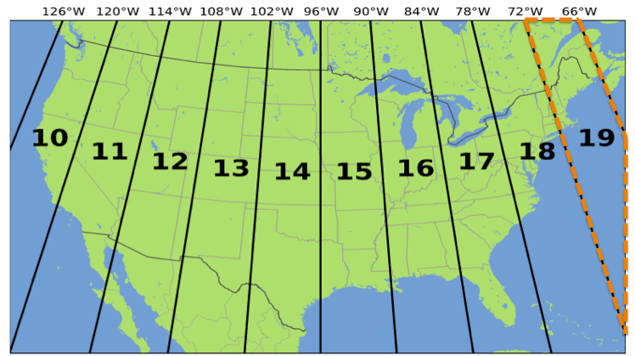

Tanner, James, February 27, 2011

**Figure: USA UTM ZONES**

In the project, the data that is used for the purpose of analysis is the marine traffic data in Zone 19 of USA.

**DATA SOURCE**

The source from where the above data is obtained is <http://www.marinecadastre.gov>.

It is the source of Vessel traffic data collected by US Coast Guard through navigation safety devices that transmit the location and other properties of vessels after every one-minute interval and the data is recorded in File Geo databases (.gdb format). It is collected through Automatic Identification System (AIS) receivers.

**File Geo database Structure (GDB)**

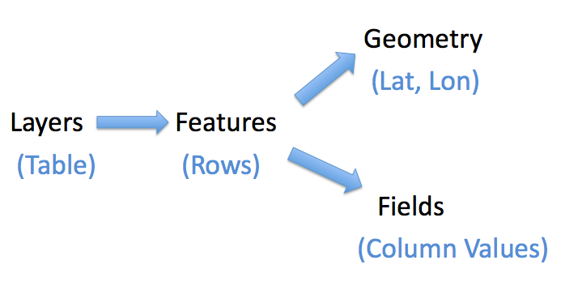

**Figure: GeoDataBase File Structure**

File Geo Database consists of different layers. Each layer consists of many features and each feature is consisted of Geometry (i.e. Latitude and Longitude points) and Fields (i.e. properties of vessels).

Layers are comparative to tables and features are like rows in the table. Further, Fields in the features are like columns in the tables.

**Layers in the Data**

Below are the layers present in the data used for the analysis in the project:

* **Broadcast layer (Used in the project)**

This layer is used in the project for analysis because it contains position reports or the geographic points (latitude & longitude)

* **Voyage layer**

This Layer contains static data for each voyage in the Zone 19 of USA.

* **Vessel Layer**

This Layer contains static data of the vessels in the Zone 19 of USA.

**Data in Broadcast Layer**

Broadcast layer has fields and geometry separately. Below are the few rows of fields present in the broadcast layer:

**FIELDS**

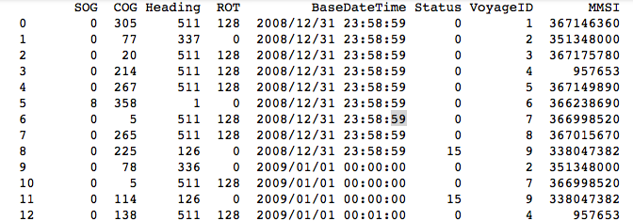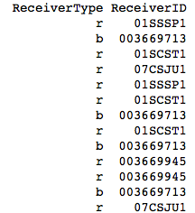

Below is the list of fields present in Broadcast layer:

* Speed over Ground (SOG)
* Course over Ground (COG)
* Heading
* Rate of Turn (ROT)
* BaseDateTime
* Status
* VoyageID
* Marine Mobile Service Identity (MMSI)
* ReceiverType (Receiver or Broadcast)
* ReceiverID

**GEOMETRY**

Broadcast Layer has geometry points encoded separately. Below are the few rows of latitude and longitude points in the given layer:

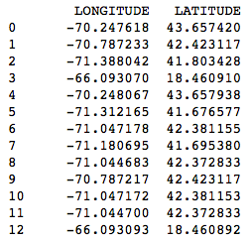

Data fields used in the project are:

* VoyageID
* BaseDateTime
* Geometry

**Tools Used**

Below are the tools used for various purposes in the project:

• **LanguagE**

* Python

• **Data Extraction**

* Geospatial Data Abstraction Library (GDAL)
* OpenGIS Spatial Reference System (OGR)

• **Data Manipulation**

* Basemap
* Matplotlib
* Pandas

• **Data Rendering**

* Folium
* Leaflet
* javascript
* CSS
* HTML

**DIMENSIONS OF THE PROJECT**

The project explores two dimensions for traffic analysis of the data. They are:

1. **Traffic Density**

The project intends to explore the traffic density of the ocean. In other words, it needs to identify the regions that have denser traffic and less dense traffic in comparison. It also tends to analyze the trends in the traffic.

1. **Traffic Direction**

The project explores the traffic direction. In simple words, it analyzes the direction in which the different parts of the traffic are moving and also what is the relative magnitude for it.

**Approach Used for Traffic Density**

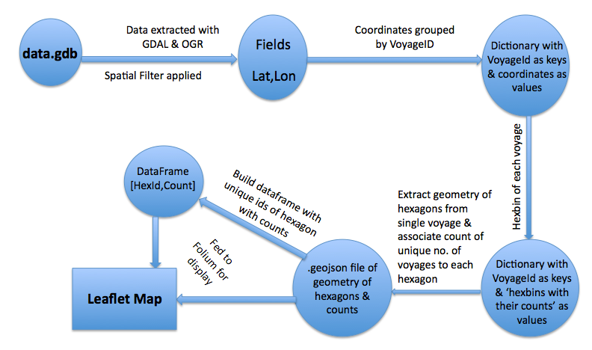

The above picture explains the approach used for the development of the analysis tool to analyze traffic density. Below is the step-by-step process for the same.

1. The data (fields & geometry coordinates) from GeoDatabase (GDB) file is extracted using the python libraries: Geospatial data Abstraction Library (GDAL) & Open GIS Spatial Reference System (OGR). Spatial filter is applied to extract only the data belonging to a particular region that needs to be analyzed.
2. Coordinates are grouped by ‘VoyageID’ to get a dictionary with ‘VoyageID’ as keys and coordinates as values.
3. Hexbin is applied on each voyage separately and dictionary with ‘VoyageID’ as keys and ‘hexbin coordinates with their respective counts’ as values.
4. Geometry of hexagons is extracted from single voyage and count of unique number of voyages inside each hexagon is associated to the hexagon.
5. Data in step 4 is formatted in Geojson (web file format to save geometry data) file that contains the geometry of hexagons and their respective counts.
6. Build a Pandas DataFrame with unique ids of hexagons and their respective counts associated.
7. DataFrame and the Geojson file are fed to ‘Folium’ library of Python that renders the final leaflet map with the hexbin layer on it.

**RESULTS OF TRAFFIC DENSITY FOR DIFFERENT REGIONS**

**Boston Region**

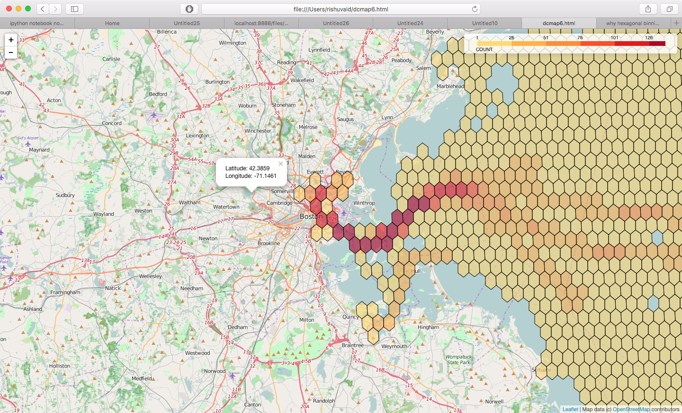

**Plymouth Region**

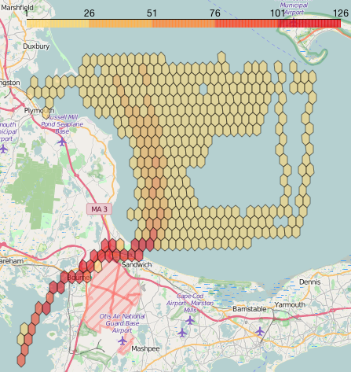

**RESULTS OF TRAFFIC DENSITY FOR DIFFERENT MONTHS IN 2009**

**January** **February**

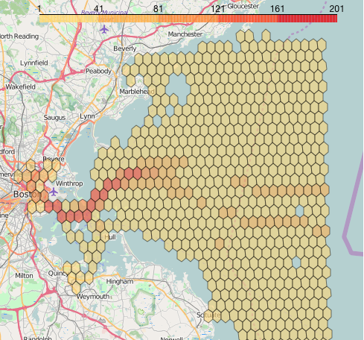 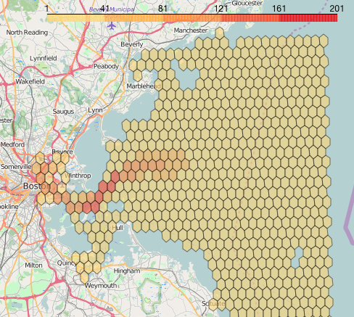

**March April**

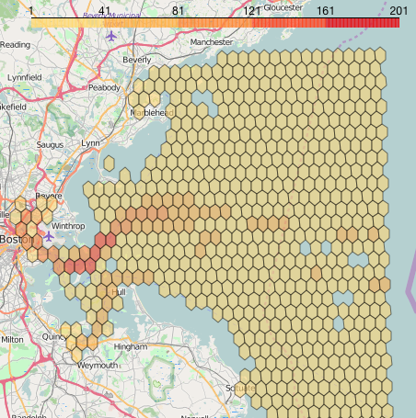 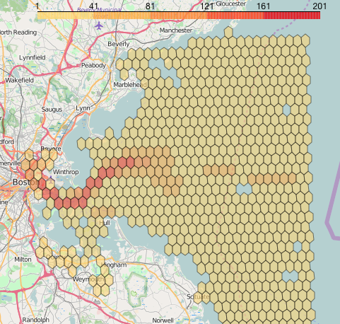

**May July**

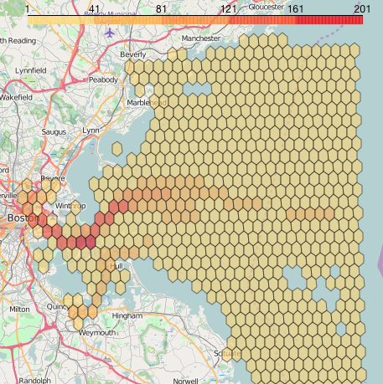 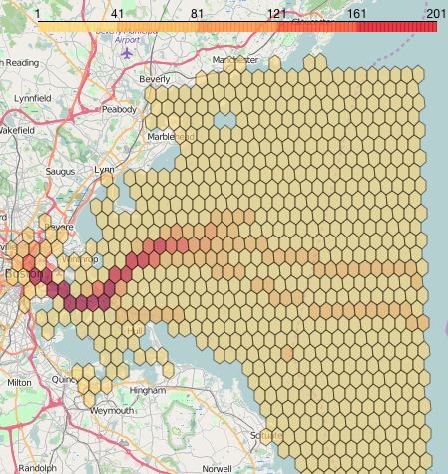

**August September**

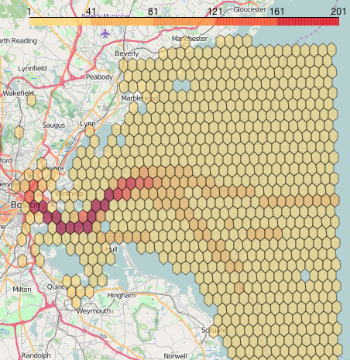 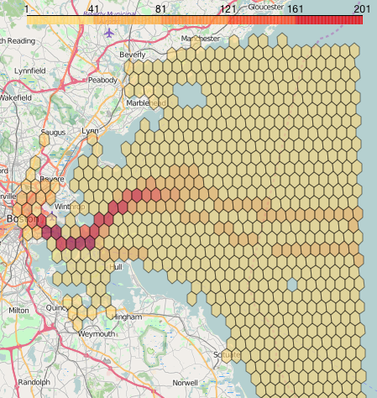

**October November**

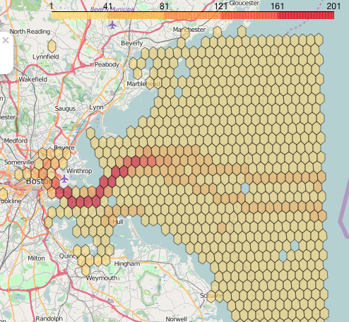 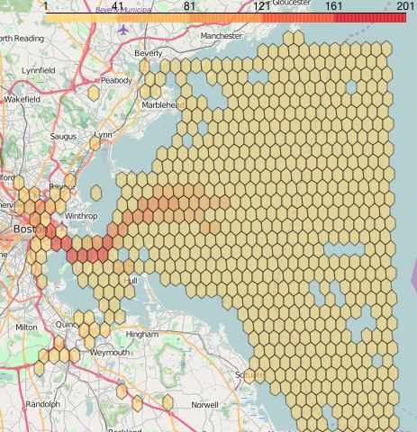

**December**

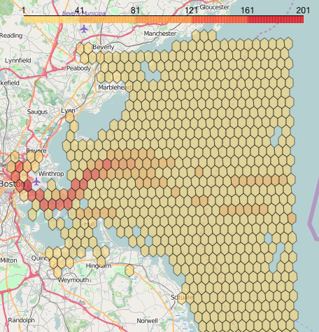

**Approach Used for Traffic Direction**

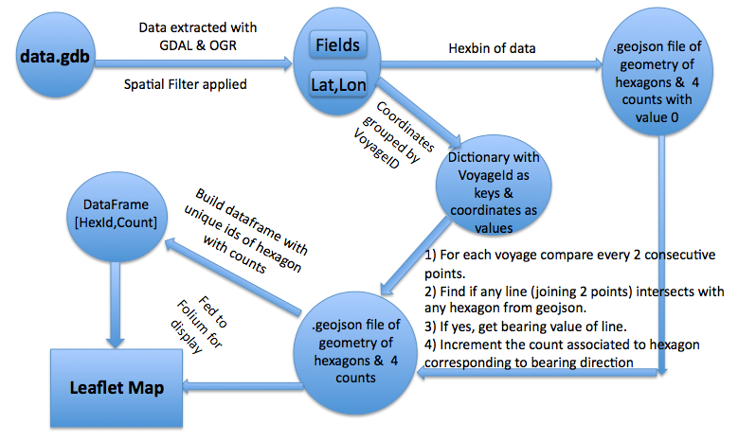

The above picture explains the approach used for the development of the analysis tool to analyze traffic density. Below is the step-by-step process for the same.

1. The data (fields & geometry coordinates) from GeoDatabase (GDB) file is extracted using the python libraries: Geospatial data Abstraction Library (GDAL) & Open GIS Spatial Reference System (OGR). Spatial filter is applied to extract only the data belonging to a particular region that needs to be analyzed.
2. Hexbin is applied on the data that returns the geometry of hexagons and the associated count of points under each hexagon. From this data, Geojson file is created that holds geometry of hexagons and four counts (count1, count2, count3, count4) initialized to 0 value. The four counts are for four geographical direction quartiles (North-East, East-South, South-West, West-North).
3. From the data in Step1, the coordinates are grouped by ‘VoyageID’ to get dictionary with ‘VoyageID’ as keys and respective coordinates as values.
4. Using the data obtained from step 2 and 3, every two consecutive points are compared for each voyage. Find if any line (line joining two consecutive points) intersects with any hexagon from the Geojson. If any of the line intersects with any hexagon, the bearing value (angle of direction with respect to geographic North) is calculated for the line to understand the moving direction of the line. Finally the count associated to the bearing value and the associated hexagon is incremented by one with every intersection.
5. The Geojson file of hexagon geometries and the four counts for four direction quartiles is obtained.
6. The Pandas DataFrame of unique hexagon ids and the count value of the direction quartile in study is created.
7. Finally the Geojson file and the DataFrame are fed to Folium for the creation and display of the Leaflet map.

**RESULTS OF TRAFFIC DIRECTION**

**North-East East-South**

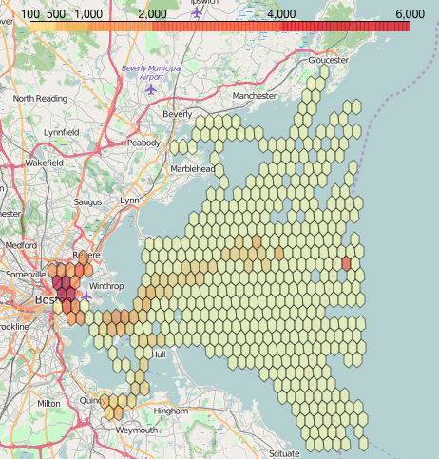 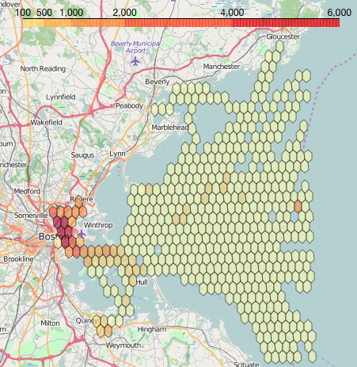

**South-West West-North**

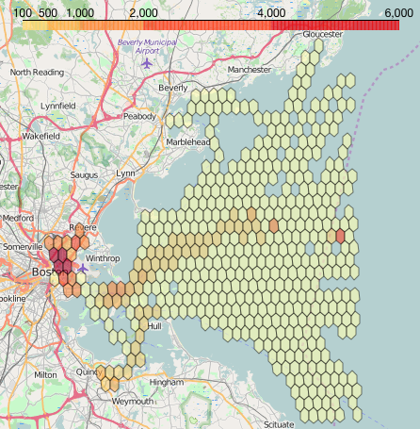 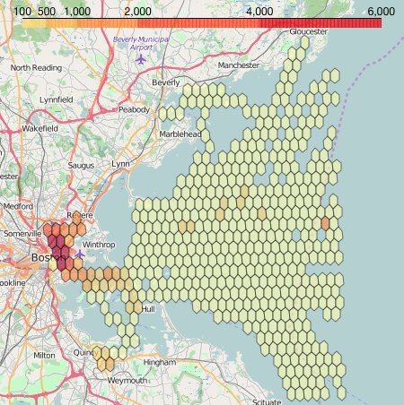

**EVALUATION**

**Traffic Density**

1. It is observed that for Boston region, the ship traffic is denser near to the land or the city. But as the traffic goes in open waters towards the ocean, it diverges in different directions and thus the density is seen getting less dense as the ships move away from the land.
2. Similarly, for Plymouth region, the traffic is less dense in the open ocean but as the ships crosses over to the other side from a narrow Sandwich near Massachusetts Military Base, the traffic automatically is seen getting denser.
3. From analyzing the traffic near Boston region for different months, it is observed that there are more number of ships in the ocean during warmer or not very cold temperatures when the water is open and is not affected by the snow. For example, the traffic is denser from the month of April to October and the number of vessels in the water starts reducing considerably as the winter approaches in the months of December to March.

**Traffic Direction**

1. It is observed that the traffic uses specific lanes or paths for moving in the water. As seen from the Boston region, the traffic moving towards North-East and South-West (directionally opposite to North-East) is using the same lanes for going away and coming reverse towards Boston city. The same pattern is seen for traffic moving towards East-South and West-North.

**FUTURE WORK**

1. The density algorithm needs to be improved in terms of computation speed. There is always the possibility to improve the algorithm’s time complexity either by changing or modifying the algorithm.
2. The direction algorithm needs improvement in some edge cases where a voyage oscillating between two hexagons affects the accuracy of results. Such a case will keep adding unnecessary counts in the direction of oscillations with respect to hexagons. There needs to be a handling mechanism for this.
3. Researching and finding a different but more appropriate visualization idiom to visualize direction on the map could do another improvement. Because direction analysis with hexagonal binning is a little difficult to interpret and thus comprehend.

**REFERENCES**

[1] Apte M., Agarwadkar Y. Y.Y., Azmi S., Inamdar A. B. (2012), Understanding Grids and Effectiveness of Hexagonal Grid in Spatial Domain

[2] Nicholas Lewin-Koh (April 13, 2011), Hexagon Binning: An Overview

[3] Sarah E. Battersby, Daniel “daan” Strebe & Michael P. Finn (2016), Shapes on a plane: evaluating the impact of projection distortion on spatial binning, Cartography and Geographic Information Science, DOI: 10.1080/15230406.2016.1180263

[4] Zuchao Wang, Xiaoru Yuan (September 28-Octobor 14, 2012), Visualization of Traffic Trajectories in Beijing.

[5] Tanner, James (February 27, 2011), Understanding Topographical Maps for Genealogists -- Part Two, Retrieved from the website: [www.genealogysstar.blogspot.com](http://www.genealogysstar.blogspot.com)

[7] Koop, David, Retrieved from the website: www.cis.umassd.edu/~dkoop/

[8] Basemap Tutorial (2014), Retrieved from the website: <http://basemaptutorial.readthedocs.io>

[9] Folium Documentation, Retrieved from the website: <https://github.com/python-visualization/folium>